

***LAB REPORT 5***

***Muhammad Rafay***

***20P-0018***

***Computer Networks***

***Sec A***

**TASK 1.**

**Configuring our router using CLI**.

**Topology**

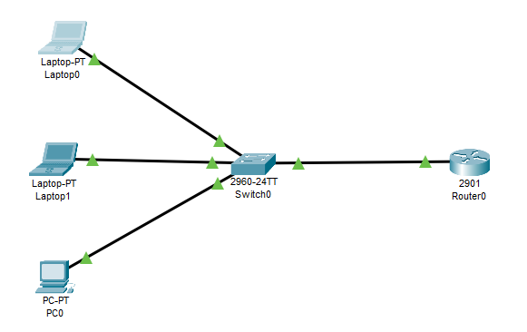

**At first I’m configuring my interface fa0/0. To act as a Default gateway for our LAN.**

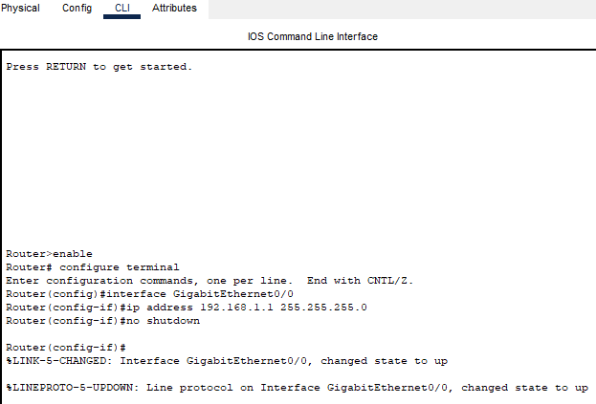

**After that I’m configuring DHCP server on the router.**

As

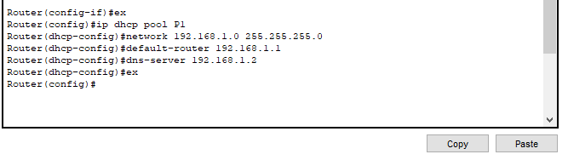

**Results .**

Laptop 0

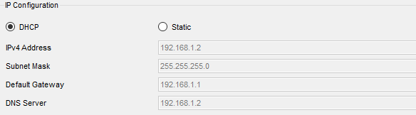

Laptop 1

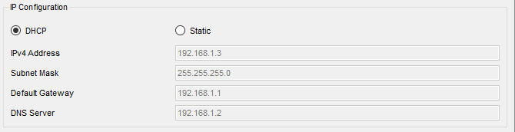

PC 0

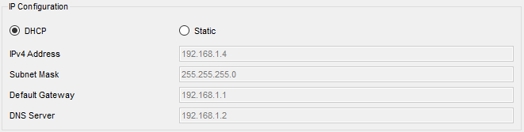

**TASK 2.**

**Topology**

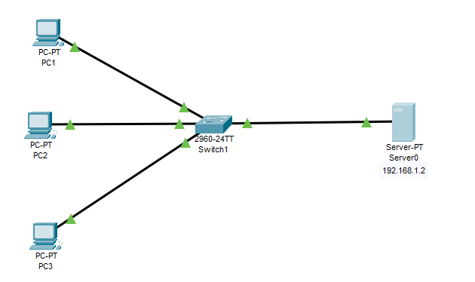

**In this task I’m configuring Static Address on the Server.**

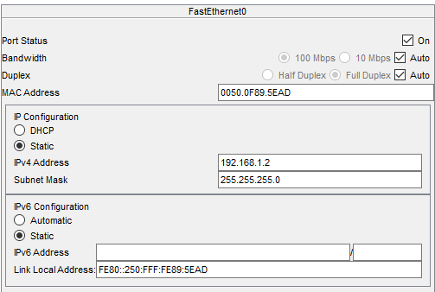

**After that I’m configuring DHCP service on the generic server.**

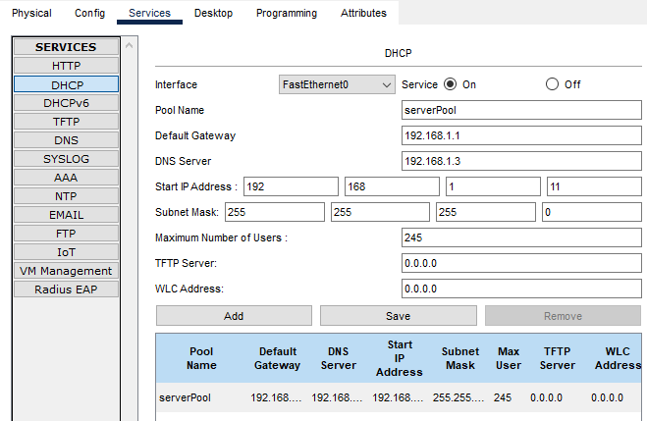

**Now assigning Ip Address to DHCP.**

**Results.**

**PC 1**

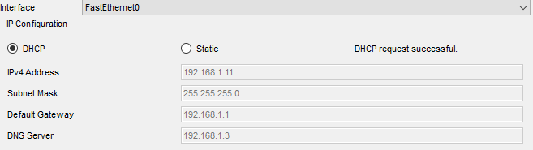

**PC 2**

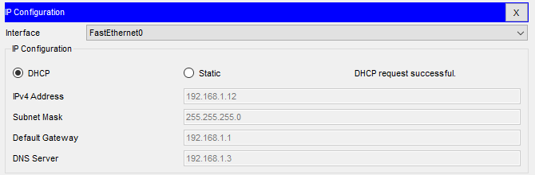

**PC 3**

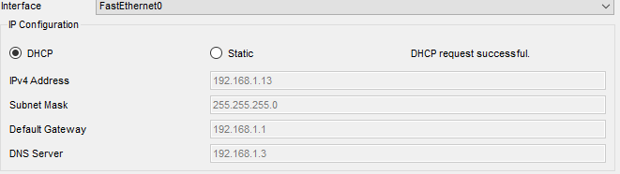

**TASK 4.**

**Topology**

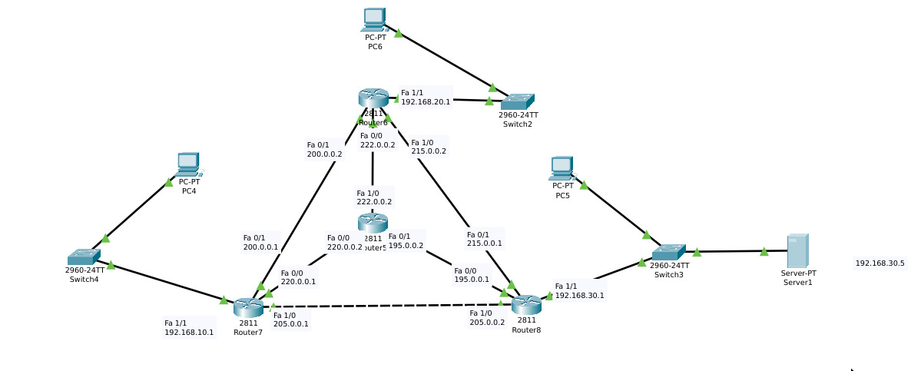

Router 5 Static Config .

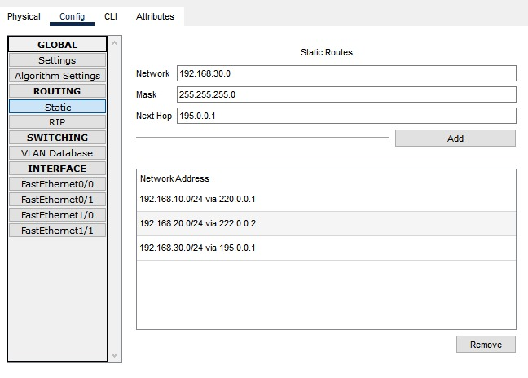

Router 8 Static Config  
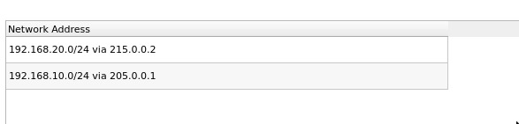

Router 6 Static Config

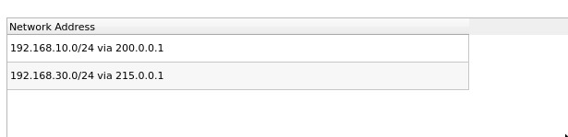

Router 7 Static Config

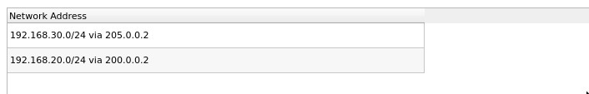

Server’s DHCP Config .

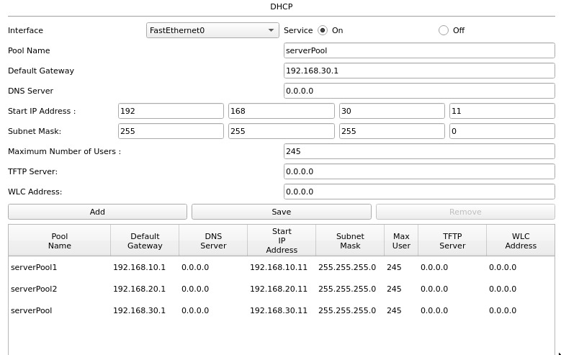

IPs Config on PC using DHCP

